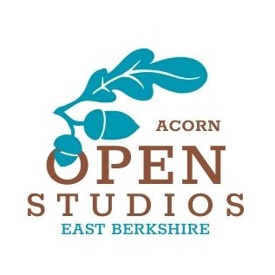
Acorn Open Studios -
Membership Criteria and Assessment
Artists working in East Berkshire, with a studio or work space they are willing to open to the public are invited to apply to join Acorn Open Studios. Their eligibility and suitability will be assessed by a minimum of three members of the Management Committee.
The core of the Open Studios is close to and East of Reading. Any artist who is further away must recognise that they will benefit less from the publicity activities of the Group and will be encouraged to create a cluster with other local artists.
There are two types of membership available – Exhibiting and Sleeping. Artists cannot join the Group as a Sleeping Member first. They should actively exhibit upon joining the group and subsequently if they cannot take part in an event, they will become a Sleeping Member. If they do not take part in three events in a row their membership will lapse.
You can apply at any time, however if print/design deadlines have passed you may not be able to take part until the following event.
Assessment aims to answer the question: “If I visited this artist and venue would I be encouraged, by the standard of work, presentation and welcome, to visit more?”
- Members must be over 18.
- Live or work in East Berkshire (primarily defined as the County of Berkshire to the East of the A33)
- Willing to help the Group achieve its aims and abide by the rules of the Group. This is a fledgling event, so success will only come if everyone works together. All must give as much as they take and the Group can not carry people who are not willing to actively contribute.
- Pay any subscription (per event) agreed by the Management Committee and purchase a banner and directional signage at cost in the first event. The subscription is non-refundable once paid.
- The member must have a studio or creative space within this area which they are able to open to the public. If they wish to share a studio venue they must explain why. But each venue must be a creative space ie no groups in church halls. Valid reasons might be accessibility to the studio, personal safety concerns, security concerns (especially relevant for jewellers), insurance restrictions etc.
- All members must promote the trail through their own networks such as mailing lists, distribution of leaflets, adding to websites, social media.
- Members must hold public liability insurance for the event.
- Membership is available to anyone without regard to gender, race, nationality, disability, sexual preference, religion or belief. Members must be willing to welcome members of the public without discrimination too.
- Members must demonstrate a good standard of work and presentation in their chosen discipline. Eligible disciplines include (but are not limited to): painting, sculpture, printing, drawing, jewellery making, ceramics, glass work, wood work, digital, photography, film.
HOW TO APPLY:
- Artists will be asked to submit their website details and social media accounts. If they have no online presence, they will be asked to submit 5 images of work and an artist’s statement. It is unlikely that someone without any online presence will be accepted. Please also outline ideas of how you will practically support the group’s aims.
- A copy of the Group’s constitution will be sent to all prospective members.
- The decision of the Assessment group is final and they will endeavour to offer constructive feedback should the application be unsuccessful.
SUBMISSION EMAIL: apply@acornopenstudios.uk

